**Academic Non-Fungible Tokens**

**Group 8**

**November 30, 2022**

**Table of Contents**

Executive Summary **3**

Introduction to Domain and Problem Space **4**

Problem Space **5**

Evaluation of User Needs **6**

Visuals and Description of Prototype System **8**

Methods Used To Evaluate Prototype **12**

Results of Prototype Evaluation **12**

Implication of Evaluation **14**

Mock-ups of Recommended Changes Based on Results of Evaluation **15**

Limitations **18**

References **19**

Contributorship Statement **20**

Appendices **20**

# 

# Executive Summary

Non-fungible tokens (NFTs) have made a meteoric rise in popularity in recent years. They utilize blockchain technology, similar to fungible tokens like cryptocurrencies. However, there is a major difference. NFTs place a unique identifier on a block of data. Whereas in the context of fungible tokens, every block has the same value. The unique identifier presents the opportunity to claim ownership or manifest uniqueness of a digital asset. In this study, we deliberate the idea of using NFTs to facilitate the validity and transferring of academic documents.

NFTs can potentially substitute academia credentials such as degrees, certificates, and attendance records. They can prevent malicious or illicit manipulation of records because NFTs are immutable or unable to be changed. To access records currently, a student must go through an administrative process that can be inefficient and slow; this in turn causes inefficiencies on the hiring manager side. This can be troublesome, especially if a student is trying to provide proof to a hiring manager of a document that is not in proximity. If replaced, NFTs in academics can increase mobility and decrease hassles with current administration formalities.

To best perform this study we chose to focus on employer’s hiring managers as our user group. Hiring manager’s jobs are to find and evaluate potential employees for a company and ensure their validity for the position. With the main demographic of currently employed hiring managers being women in their mid forties who utilize people skills, we developed a simple prototype. This prototype uses email and a website which adheres to our user group’s needs.

In order to evaluate the viability of NFTs as a means for hiring managers to receive academic records, a usability test was conducted. As a part of the usability study, participants were required to respond to a questionnaire and navigate to an NFT diploma via a paper prototype. The results of the study indicated that users were generally familiar with NFTs and open to learning new technologies, but they were unsure whether the existing process for sending academic documents needed to be modified or if NFTs were trustworthy. Furthermore, all user study participants were able to successfully navigate the paper prototype in an average of 34.84 seconds.

After conducting the usability study, changes were recommended to improve the paper prototype as well as the questionnaire. The most notable change included notifications via email to remind hiring managers to return an NFT to the sender, as NFTs can only be held by one person at a time. We recognized certain limitations to our usability study, such as attitudes towards NFTs and lack of accessibility to the user group in focus.

Overall, after conducting research and the usability study, we believe that NFTs could potentially be a viable option for storing and verifying academic records; however, the user need for such a technology might not be strong enough to warrant this technology to become commonly used within academic verification.

# Introduction to Domain and Problem Space

In an increasingly paperless world, society is always finding ways to digitize processes. Most business transactions have been successfully implemented to be carried out on computers and the web. Adobe created the PDF, an electronic document that could be exchanged via the internet. This was a major breakthrough that was far more efficient than a fax.

Some issues can be identified, however. Namely, online documents can easily be doctored. Computer users have access to many tools that can easily modify documents. The integrity of records and reports is very important. Despite being illegal and unethical, forgery is common and a problem.

This report describes how non-fungible tokens could be used to ensure integrity of official documents, specifically in academia.

Non-fungible tokens utilize blockchain technology. Gaining major traction with the rise of cryptocurrencies, or fungible tokens, blockchains have a variety of applications. Blockchains are a linear set of data blocks. Everytime a block is added to the end, it points to the “parent” or previous block. This relationship’s integrity is verified through cryptographic methods [1]. For cryptocurrencies, every block has the same value. It can be equated with the US dollar bill as every one dollar bill has the same value. Ethereum is one of the most popular blockchains. Some privacy aspects still remain ambiguous. A user’s activity and transactions are public, however the identity of those involved is private. This is the concept of pseudo-anonymity [2]. It is possible for one’s identity to be discovered with diligent sleuthing from a third party.

NFTs allow data blocks to inherit different values. A unique value is stored on a block, therefore the blocks are non-identical and unique [3]. For example, if a celebrity signed a one dollar bill, the value of the bill would change. This presents the opportunity of proof of ownership and individuality.

Employers are known to request academic transcripts and other academic documents when a newly graduated student is in the hiring process. There have been instances where students have doctored transcripts to feign better grades. A goal of this study is to create a reliable way to retrieve a document from a university that is “notarized” with an NFT. In addition, one must go through the administrative process to retrieve official academic documents. The efficiency of this process can vary and costs money. Ideally, NFT based documents will speed up the process, save money, and ensure integrity.

# Problem Space

When discussing NFTs in Academia, there must be an assessment that gauges the issues with the current system of academic records that is used in the present day. In recent years, academic records can be divided into three different subgroups. These categories are divided in parallel to a hierarchy according to its importance of security from the user's perspective.

The first type of academic records is the most commonly known as *“Permanent Records”.* These records are fixed and include any information such as your academic transcript, standardized test scores along with any accident/incident reports the student may encounter during their time at a given school/university. [13] Family Educational Rights and Privacy Act (FERPA) has no input or regulation on how long permanent records should be obtained by the school/university. This means it differs from state to state, particularly in South Carolina, they can be held without time limitation.[13]

Next, there are *“Temporary Records”,* which most states instruct that these must be maintained for at least 5 years after the student stops attending the school/university. [13] These records are ones that may require a release of information. It can range from more causal records, such as extracurricular activities and awards, to more private documents such as disciplinary information, to reports of psychological evaluations. [13]

Lastly, the final type of information is “*Directory Records”.* These records are ones that are released to the general public. It can include anything from your Name, Email, Grade Level, Gender Identity, Major, etc. Students at Clemson University attain this information through university affiliated sites/apps such as iRoar and the my.Clemson app. [14]

There are several problems that arise regarding the security and the obtaining of these records. First and foremost, most academic records can easily be forged. With advanced technology tools such as Photoshop and other photo editing software, screenshots and digital photo copies of records are not as secure as it could be.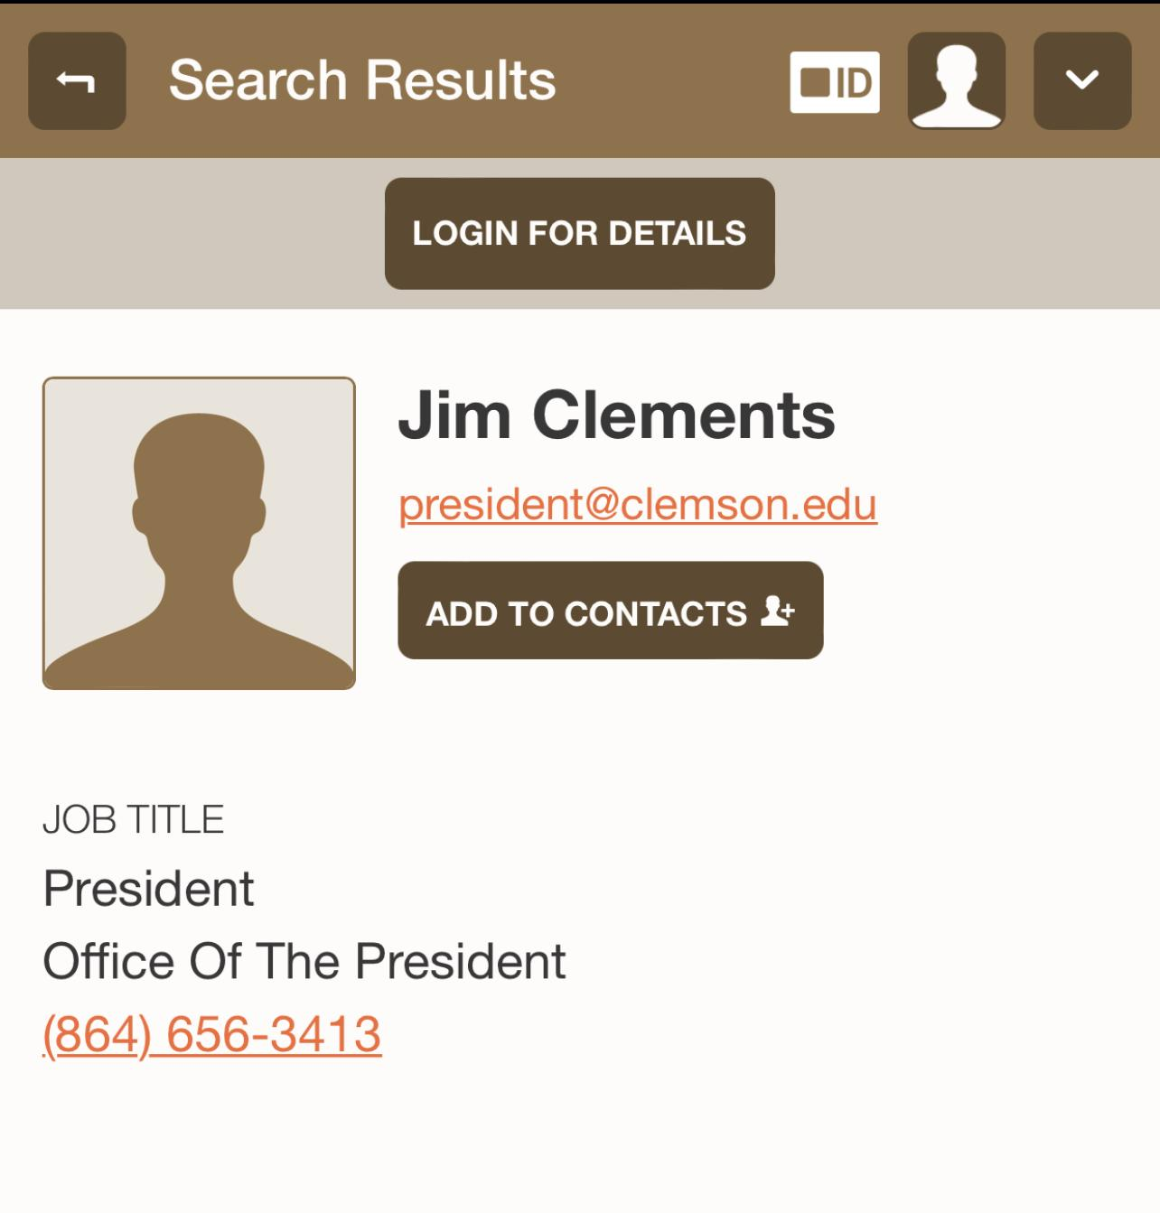

Furthermore, many dependencies are required before being able to receive a student's records. Many schools/universities, including Clemson University will withhold all a students records, most notably a transcript, if that student has withstanding fees. Other schools may use third party vendors to generate these records, which have specific guidelines to follow that may impact the students' accessibility to efficiently obtain these records[12].

The most typical issue with the current system of academic records is the entire process itself is inefficient. Most universities and systems have an allotted processing time to successfully verify these records. On average a traditional transcript can take up to two to four business days to be sent to a student [15]. Therefore, this can significantly slow down the hiring process that hiring managers conduct for new job openings.

# Evaluation of User Needs

The core of any study is to fully understand and analyze a user group that will potentially use the invention. Academic non-fungible tokens are an innovation that crosses multiple user groups including: the students that would need them created, the school who supplies them, and the employer who receives and uses them for hiring.

The main premise behind academic non-fungible tokens is to make verification of records simplified and secure. This creation of a more secure format for academic records has the biggest impact on people who have to check its validity constantly. For this study on non-fungible tokens in academia, the primary focus is on employer’s hiring managers.

A hiring manager’s job at a company is to identify a skill set for a pool of applicants and seek out new candidates that fit their own criteria. They perform extensive research into the applicant’s legitimacy to make sure that they fit the team’s requirements and culture. Hiring managers make the final decisions on all hires and handle orientation and onboarding for the new employee.

Demographically, according to Zippia [4], the United States has around twenty six thousand hiring managers currently employed with fifty three percent being women as of 2019. Additionally, the average age for hiring managers is forty six years old with the most common ethnicity being White (65.10%). On the educational side, 75% of current hiring managers have their bachelors degree while around 11% have a graduate masters degree. The distribution of majors among hiring managers is depicted below. Among these degrees, the most common majors for current hiring managers are: Business, Psychology, and Human Resources Management.

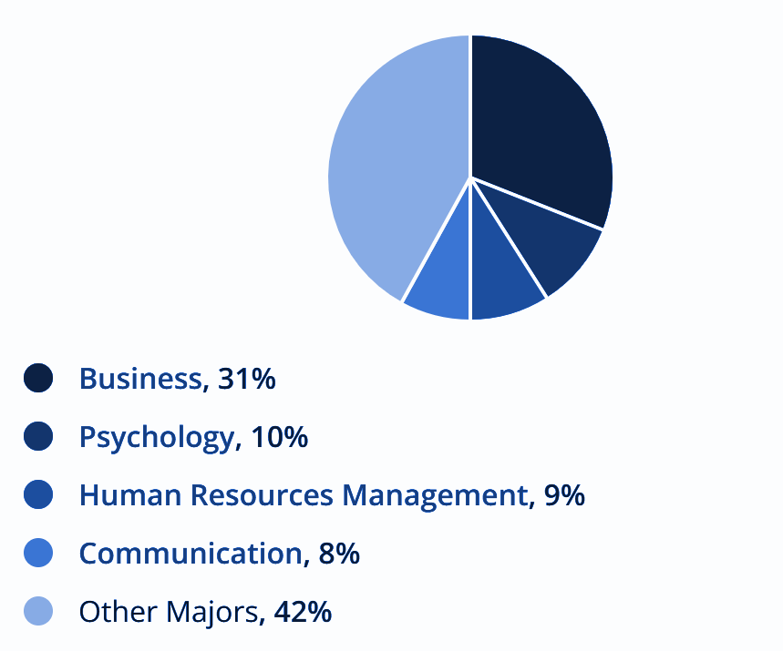

These hiring managers use people-based skills to tackle their objective including: customer service, client relationships, and human resources [4]. Notice how hiring managers do not have advanced technology skills to be hired by a company. Instead, they mostly need to be able to handle people problems.

Part of the research for a new potential employee is an educational background check which checks if the applicant has the correct degree specified (associate, bachelor, masters, etc.), correct final grade point average (GPA), and if/when the candidate finished their degree. According to Intelligent [5], the educational background checks cost around $15 for every applicant researched by the hiring manager. Also, more than half of all hiring managers check an applicant’s educational background. Common methods they use to check an applicant’s legitimacy are third party web applications (checkr.com, authenticate.com, goodhire.com, etc.). This means that hiring managers mostly use a computer rather than a mobile device to do their work [6].

Through the analysis of hiring managers above, we developed our prototype system to fit our user needs. In general, we know that the hiring managers currently are in their mid forties, are women, and use a computer to do their work. The prototype developed uses email and a website to send and receive academic non-fungible tokens between the hiring manager and the potential employee. Email was decided to be a key feature due to the fact that 91% of internet users from ages 45 to 64 use emails as well as 95% of ages from 25 to 44 [16]. This coincides with the fact that the average age of hiring managers is 46 years of age. Another reason why email was a key component in our user study is because according to Pew Research Center [17], “Women send and receive email more than men. Some 94% of online women use email… [and] women are more likely than men to value their email with friends, family and work colleagues … It improves the work climate as well.”

With thorough analysis into our user’s characteristics and demographics, we concluded that our prototype using email and a website would fulfill our user group’s needs.

**Identification and Evaluation of Existing Technologies**

As previously mentioned in the problems section, the current system that is being used to obtain these academic records is inefficient in the grand scheme of the hiring process as a hiring manager must wait to receive these academic records. There currently are no systems in place in regards to the implementations of NFTs for academic records.

Currently if a Clemson University student wishes to see an unofficial transcript, the process is fairly short and easy. All the student must do is log into iRoar, but this can not be done if a student has fees. However, for an official transcript third party services like Parchment may be used. Then a student must pay the vendor to process the university documents with an additional delivery fee to send to a student's desired location.

In recent years, there have been a few cases of NFTs being used to buy/sell real estate. People buy assets and sell them as NFTs so that a digital record is kept displaying the ownership of the assets as well as logging transactions that may occur for a certain property. It makes actions easier, faster and more efficient due to it being more secure and explicitly transparent. Each blockchain ledger supplies a compilation of every transaction from previous buyers, investments, legal disputes and more [11].

# Visuals and Description of Prototype System

A paper prototype was constructed in order to evaluate the viability of replacing academic documents with non-fungible tokens. The paper prototype mimicked the setup of a traditional computer screen. The system was designed to be viewed on a laptop or desktop because hiring managers are more likely to review academic records via a traditional computer rather than a mobile device [6].

The initial screen that user testing participants encountered in our paper prototype was an email inbox. In the prototype, users received notifications that they had received a non-fungible token through an email. Email was selected as the method for notification because the average person checks their email about 15 times per day [7].

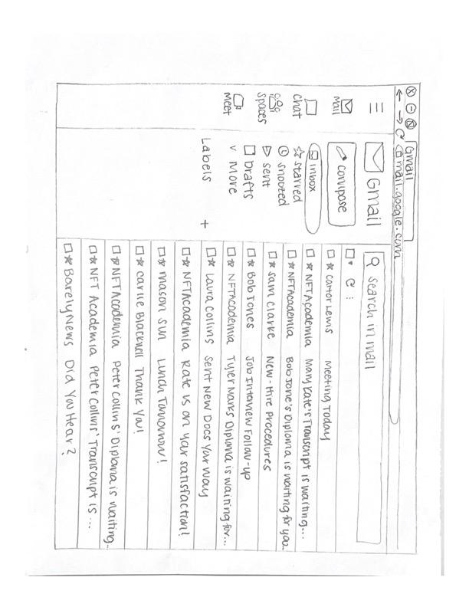

The second screen that users encountered was the body of the email notification. Here, users encountered two buttons. One button, labeled “view,” took users to the non-fungible token that they had received. The other button, labeled “return to sender,” returned the non-fungible token to its previous owner.

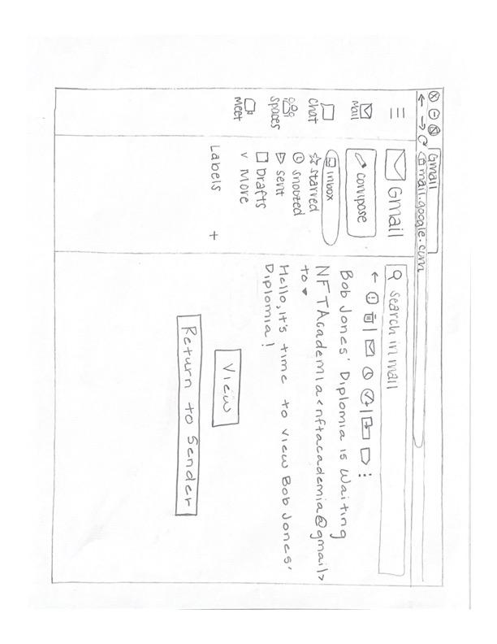

If users selected the button labeled “view,” they would view the non-fungible token that had been in an external application. On this screen, users encountered the “return to sender” button again. This button is displayed multiple times throughout the paper prototype because it is very important that hiring managers return academic records to job applicants. Since non-fungible tokens are unique [8] and can only be held by one person at a time, a job applicant would not have access to their academic records while the hiring manager held them.

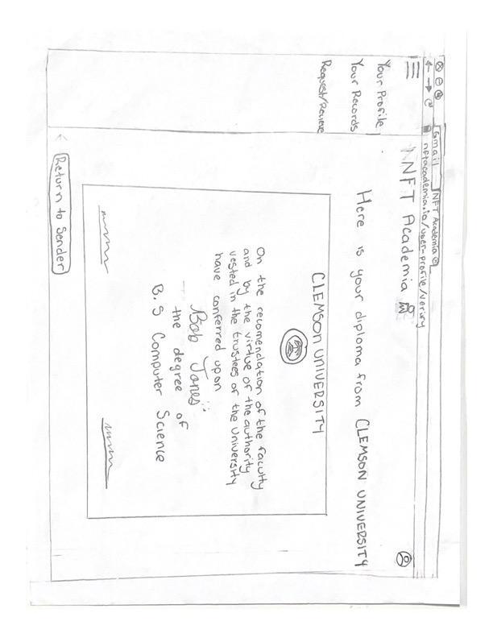

If the user selected the “return to sender,” the user would encounter an additional screen that explained that they no longer had access to the non-fungible token.

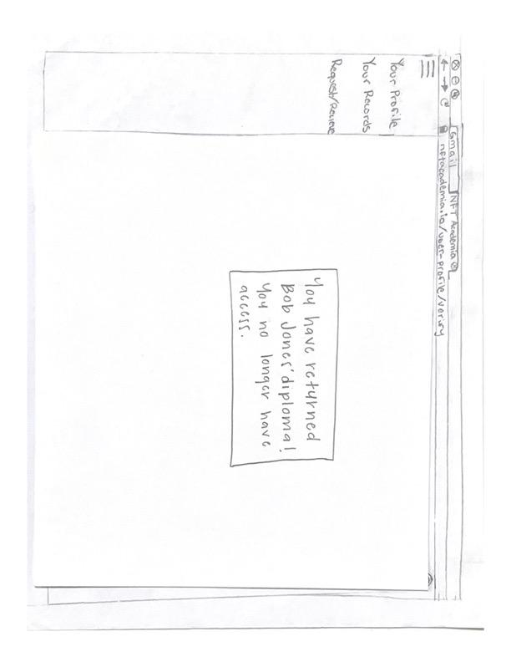

# Methods Used To Evaluate Prototype

In order to evaluate the prototype, a usability test was conducted. Users were asked to complete a questionnaire before being presented with the paper prototype. The questionnaire aimed to assess users' attitudes towards non-fungible tokens and the academic document retrieval process. Furthermore, the questionnaire sought to determine whether hiring managers would use the prototype system if it developed.

After users were presented with the opening page of the paper prototype, they were instructed to open the email that informed them that they had received Bob Jones’ Diploma. After viewing the email, participants were asked to view Bob Jones’ Diploma. Then, users were instructed to return Bob Jones’ diploma.

# Results of Prototype Evaluation

**Questionnaire**

The questionnaire revealed the general attitudes of users toward non-fungible tokens. All user study participants reported knowing about non-fungible tokens, and the 80% of participants reported that they were willing to learn new technology. Despite reporting a willingness to learn new technology, only 60% of users declared that the process for verifying a job applicant's education needs to be improved. Furthermore, only 60% of participants thought that non-fungible tokens should replace academic documentation, and only 20% of participants were certain that non-fungible tokens are trustworthy. Overall, the results of the questionnaire were mixed.

**Task Completion Success Rate**

During the usability study, success rate and time of task were recorded. Users were considered successful if they viewed and returned Bob Jones’ diploma. While users 4 and 5 successfully opened the non-fungible token, they did not complete the task using the ideal sequence of actions. Users 4 and 5 did not immediately open the email notifying them that they had received Bob Jones’ diploma. Instead, users 4 and 5 opened an email scheduling Bob Jones’ interview. This data is represented in the table and graph below.

**Task Completion Rate**

| **User 1** | **User 2** | **User 3** | **User 4** | **User 5** | **Completion Rate** |
| --- | --- | --- | --- | --- | --- |
| ✓ | ✓ | ✓ | ✓ | ✓ | 100% |

**Task Completion Rate**



**Time on Task**

In order to determine if retrieving academic transcripts via non-fungible tokens is faster than traditional methods, users were timed from being presented with the paper prototype until they reviewed and returned Bob Jones’ diploma. The average time for all users to complete the task was 34.84 seconds. Furthermore, Users 1, 2, and 3 completed the usability test using the ideal sequence of events. As a result, their times are lower than users 4 and 5. The average time for users that completed the task by using the ideal sequence of events had an average completion time of 25.29 seconds. This data is represented in the table and graph below.

**Time on Task**

| **User 1** | **User 2** | **User 3** | **User 4** | **User 5** | **Avg Time** |
| --- | --- | --- | --- | --- | --- |
| 24.47 | 27.33 | 24.08 | 40.76 | 53.78 | 34.84 |

**Time on Task**

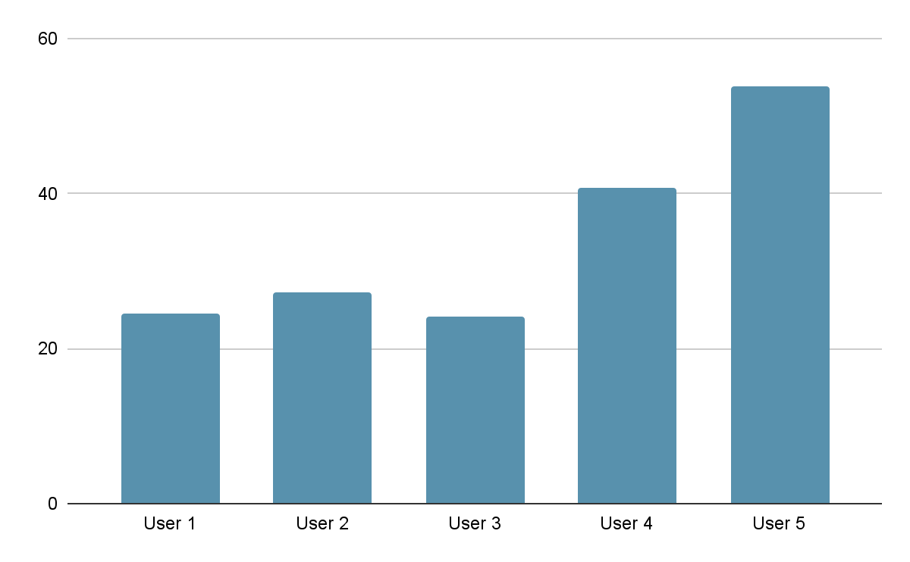

# Implication of Evaluation

The usability study showed that the subjects were able to reach the desired end goal despite some varying times and errors.

Beginning with a questionnaire, we found that most subjects had at least a basic understanding of NFTs. All subjects had heard of non-fungible tokens and were aware of the recent growth. This can be attributed to the users being in a technological major or minor. Therefore, they are more likely to be aware of recent changes in tech and more willing to learn about them. As this is a higher level university course, many users have been familiarized with the process of transferring official academic records (i.e. transcripts) to possible employers. The in-place process of requesting documents from the university costs money and time. Therefore, it is understandable that some users felt there was a need for change in the process.

Next, the study used an interactive activity that presents the possible flow of transferring academic documents as NFTs. The user, in the role of a hiree, began the process in their email. We found some users would select the incorrect email despite the given context. Users may have looked for buzz-words, in this case the applicant’s names, rather than taking in the entire context. As a hiring manager becomes more familiar with the system, this problem would likely diminish. Our focus was to make a user-friendly flow to allow the hiring manager to easily verify an applicant’s documents. After the correct email was selected, the users were able to easily navigate the rest of the system. This included viewing the NFT-embedded document and returning it to the applicant. If the user was unfamiliar with the workings of non-fungible tokens, it seemed important to reduce confusion on the user interface side.

Overall, all users were able to successfully complete the task. As previously stated, the largest setback was users rushing through the email portion. However once a mistake was realized, the user was able to amend it on their next attempt. We found that it is important to have an easily accessible path to view the official documents and return them to the users. This would mitigate confusion and allow the NFTs to be returned to the applicant as only one person can hold it at one time.

# Mock-ups of Recommended Changes Based on Results of Evaluation

After conducting the usability study, there were several improvements that could improve the prototype. First, a separate web application could be developed for the transfer of non-fungible tokens. However, this change would require an additional user study, and a new unfamiliar web portal might cause further confusion among hiring managers. Globally, out of the total people who have access to the internet, over 75% utilize email [9]. Therefore, hiring managers are likely already familiar with email applications, and they would likely learn to transfer non-fungible tokens quicker through email as opposed to a novel webportal. The remaining proposed changes focus on improving the system within the email application.

Some study participants experience difficulty finding the email notifying them that they had received a non-fungible token within their inbox. In the response to this finding, emails related to the sharing of non-fungible tokens should be highlighted. This change is pictured below.

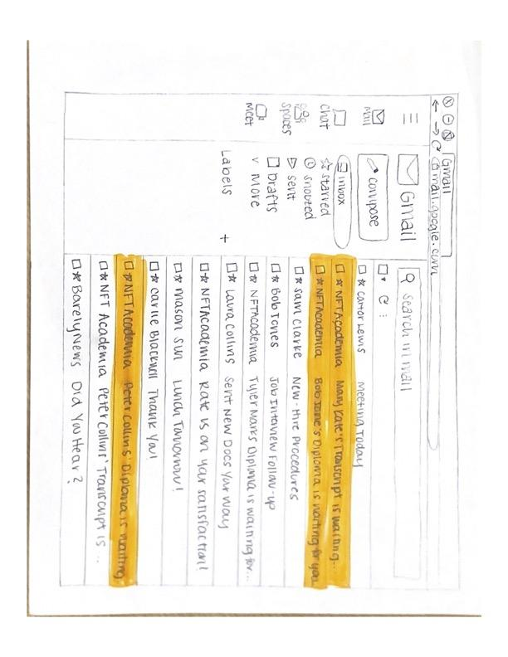

Due to the uniqueness of non-fungible tokens, a non-fungible token can only be held by one person at a time. There could be potential ambiguity and delay when transferring non-fungible tokens between employees and hiring managers as a result of this. Therefore, additional adjustments to the paper prototype could include an email notification to remind hiring managers to return the non-fungible token to the sender.

For instance, the sender could set a return date and time upon sending the non-fungible token to the hiring manager. The non-fungible token would automatically be returned to the sender upon that time. More specifically, the hiring manager could be notified of the return date within the initial email. This modification is pictured below.

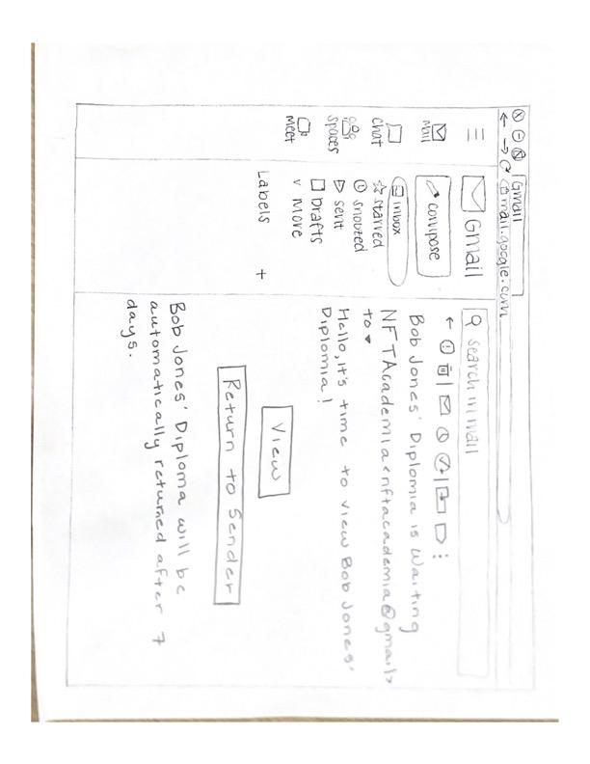

Next, hiring managers would receive an email when 50% and 75% of the time passed for them to hold the non-fungible token. Each email would prompt the hiring manager to return the non-fungible token if they wished to do so. Finally, they would receive a notification of the email being returned to the sender once the return date and time was reached.

Further, the questionnaire could be changed to include more specific information and questions to hiring managers and to the prototype. Additional inquiries to evaluate attitudes towards NFTs could include first asking if they conduct education verification within their hiring process. If the answer is yes, ask further questions concerning the method and platform of verification and attitude towards the current form of verification. If the answer is no, ask hiring managers why they do not deem education verification necessary. Questions could also be asked about any past experiences with education fraud and determine the percentage of hiring managers who have actually encountered this problem. In doing this, there would be a better understanding of the user's need for potentially using NFTs as a means for verification within academia.

# 

# Limitations

Firstly, the user study revealed that user attitudes towards NFTs are not an entirely convincing argument for NFTs in academia. During the usability study, 80% of users are willing to learn new NFTs; however, only 20% actually deem NFTs trustworthy. Furthermore, only 60% of users think that using NFTs would be an improvement to the current education verification process. Therefore, a potential limitation is a lack of actual desire for a change within the education verification process among hiring managers.

However, since the study’s participants were not representative of the ideal user group demographics, the results of this usability study are limited. Hiring managers have a different set of knowledge and skill sets than college students, who actually made up the participants of the study.

Furthermore, different people use and understand different platforms for email. Gmail was selected as the platform for the usability study since it is one of the more commonly used platforms. However, some people may not have experience with Gmail which could make them less efficient compared to those who have utilized it before.

On an entirely different note, using NFTs has an environmental impact that might discourage users from utilizing them. Each time a NFT is sent or received, it leaves a carbon footprint of 48kg CO_2 for each transaction made [10]. Of course, NFTs are not the main contributor to climate change; however, they are a contributing factor. More specifically, if a hiring manager is interviewing for 10 roles, and considering 4 candidates per role, they contribute 3,840kg CO_2 for receiving and returning a candidate's NFT. This number would increase if a candidate were to send multiple academic NFTs.

# 

# References

[1] Michael Nofer, Peter Gomber, Oliver Hinz, and Dirk Schiereck. 2017. Blockchain - Business & Information Systems Engineering. (March 2017). Retrieved October 16, 2022 from https://link.springer.com/article/10.1007/s12599-017-0467-3

[2] Ferdinand Regner, Andre Schweizer, and Nils Urbach. 2019. NFTs in Practice - Non-Fungible Tokens as a Core Component of a Blockchain-based Event Ticketing Application. ACM.

[3] Aarthi Anand. 2022. What are nfts and why are they so controversial? (July 2022). Retrieved October 16, 2022 from https://clsbluesky.law.columbia.edu/2022/07/19/what-are-nfts-and-why-are-they-so-controversial/

[4] Anon. What is a recruitment manager? | career path and overview. Retrieved November 28, 2022 from https://www.zippia.com/recruitment-manager-jobs/

[5] Intelligent.com Higher Education Team. 2022. Is your college degree worth it? - half of hiring managers don't check education credentials. (March 2022). Retrieved November 9, 2022 from https://tinyurl.com/45bud2hp

[6] Frank Gillett. 2017. Employees use multiple gadgets for work - and choose much of the Tech themselves. (July 2017). Retrieved November 28, 2022 from https://www.forrester.com/blogs/12-02-22-employees_use_multiple_gadgets_for_work_and_choose_much_of_the_tech_themselves/

[7] Mark Murphy. 2016. The way you check email is making you less productive. (September 2016). Retrieved November 28, 2022 from https://www.forbes.com/sites/markmurphy/2016/09/18/the-way-you-check-email-is-making-you-less-productive/

[8] Anon. Non-fungible token. Retrieved November 28, 2022 from https://www.britannica.com/topic/non-fungible-token

[9] L. Ceci. 2022. Number of e-mail users worldwide 2017-2025. *Statista* . Retrieved November 28, 2022 from https://www.statista.com/statistics/255080/number-of-e-mail-users-worldwide/

[10] Jiahui Qui. 2021. What Are NFTs, And What is Their Environmental Impact? | Earth.Org. *Earth.Org*. Retrieved November 28, 2022 from https://earth.org/nfts-environmental-impact/

[11] Anon. 2022. Council post: Guide to using nfts in real estate. (October 2022). Retrieved November 9, 2022 from https://www.forbes.com/sites/forbesbusinesscouncil/2022/08/04/guide-to-using-nfts-in-real-estate/?sh=4b42c6945e8a

[12] Anon. FERPA. Retrieved November 9, 2022 from https://www.clemson.edu/administration/ogc/selected-policies/ferpa.html

[13] Anon. Records and school reports - records custodian, categories. Retrieved November 9, 2022 from https://education.stateuniversity.com/pages/2357/Records-Reports-School.html

[14] Anon. 2022. my.Clemson Directory Retrieved November 9, 2022 from

my.Clemson App

[15] Anon. Transcripts. Retrieved November 15, 2022 from https://www.clemson.edu/registrar/student-menu/student-records/transcripts.html

[16] Published by L. Ceci and Sep 13. 2022. U.S. e-mail usage by age 2021. (September 2022). Retrieved November 29, 2022 from https://www.statista.com/statistics/271501/us-email-usage-reach-by-age/

[17] Deborah Fallows. 2020. How women and men use the internet. (August 2020). Retrieved November 29, 2022 from https://www.pewresearch.org/internet/2005/12/28/how-women-and-men-use-the-internet/

# Contributorship Statement

"This assignment was completed by John Mathews, Trevor Nouvel, Emma Grace Powers, Kathryn Smith, and Ferrin Threatt. All members completed the executive summary and reviewed the final product. John’s role in completing this assignment was to complete the section on evaluating user needs. Trevor’s role included introducing the problem space and the implications of the user study. Emma Grace wrote the sections on proposed changes and limitations. Kathryn described the prototype and the methods used to evaluate the prototype as well as the results of the evaluation. Ferrin evaluated existing technology and their shortcomings. Group members consulted the material listed in the references.”

# Appendices

Questionnaire

* What are NFTs?
* Are you willing to learn new technology?
* Does the process for verifying a job applicant's education needs to be improved?
* Should NFTs replace academic documents?
* Are NFTs trustworthy?